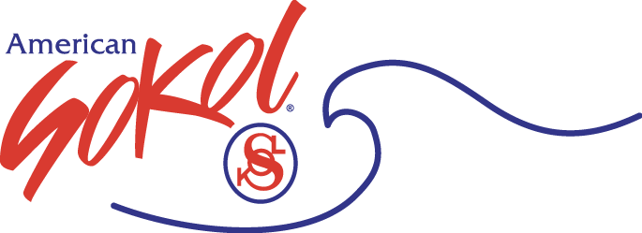

Q&A American Sokol SafeSport Protocol

- I tried taking this training at www.Safesport.org/training but because I do not have an USAG membership, I could not register.
If you do not have an USAG membership you can still you that link but you need to click on where it says “If you are not a member of a National Governing Body, you can access the training by clicking here.
OR

- Go to www.athletesafety.org. Google Chrome or Firefox are recommended for the best user experience.
- Click on “Training” from the homepage or from the “Menu” in the upper left corner of the screen.
- Select “SafeSport™ Trained” from the catalog and “Add to Bag”.
- Select “Checkout”.
- You will then select “Register” to create your account and profile. Fill out the required information. (Note: you can select “Not Affiliated” for Membership if your organization is not listed in the drop down menu.)
- An email will be sent to you to confirm your account. Open the email and click “Confirm Email Address”. You can then sign in.
- Once you’ve signed in, you can purchase the course from your shopping bag in the upper right corner.
- Once you’ve successfully purchased the course, you will be able to complete it from your Learning Dashboard.

If you experience any technical difficulties while taking the training, please contact the SafeSport Help Desk at help.desk@safesport.org or call 720-676-6417. The Help Desk hours are:
Monday – Friday 8:00am – 9:00pm EST; Saturday – Sunday 12:00pm – 5:00pm EST.

Remember to download and save your SafeSport™ Trained certificate upon completion of the course.

- Is there a minimum age for taking SafeSport?
18 is considered the minimum legal age for taking this training.

- We have helpers/volunteer who are under 18 (14-17), should they take this training?
While they can take it we are requiring anyone under 18 to take the “Youth Athlete Training” at no cost. When they reach the legal age of 18, they must then take the SafeSport Training.

- Once you have taken SafeSport Training and passed do you have to retake it?
At the present time there is no ruling that this training has to be retaken. However Safesport and The Olympic Committee is reviewing this statement for reconsideration. SafeSport stated that most organizations are indicating retaking this training every 1, 2 or 3 years. American Sokol is requiring retaking this training every 3 years at this time. Unit may require their instructors and volunteers to retake this training more often but American Sokol will only reimburse every three years for the same instructor or volunteer. Please remember if your instructors or volunteers are not members of USAG or AAU they will also need to have a background check.

- My unit is not paying for this training so can I turn in my information that I took this training for immediate reimbursement directly to me?

The process for reimbursement as stated in our SafeSport protocol is as follows:
  - Only Units can request reimbursement for their members or others who interact with youth participants in an ongoing basis in their unit.
  - Units will need to supply us with names of those taking this certification as well as a copy of their certificate of completion. The units are responsible for vetting the people they are submitting for reimbursement to make sure they have successfully completed this training and have a valid certificate. For those individuals who have already successfully completed this training, Units may also submit their information for reimbursement.
  - This information will need to be turned in to RiskMgmt@american-sokol.org by the 20th of August, October and December, 2019. If the money runs out before the end of the year a notice will be sent out that we can accept no more names for reimbursement at this time. Because we have already passed the August 20 deadline we are changing the first deadline to September 20, 2019; the other deadlines remain the same.

- Is there a form that Units are to use for reimbursement for this training?
Below is a sample form which can be used. The full form will be on our website.

UNITS SUBMISSION FOR REIMBURSEMENT
FOR INSTRUCTORS AND VOLUNTEERS
FOR COMPETING SAFESPORT TRAINING

Unit Name: _______________________ Submitted by: _____________________

Instructors/Volunteers who
completed training: Class/Activity Involved with:
1.
2.
3.
4.
5.
6.
7.
8.
9.
10.
11.
12.
13.
14.
15.
16.
17.
18.
19.
20.

Return this completed form along with copies of SafeSport Trained certificates to:

RiskMgmt@american-sokol.org

